Machine Learning Approaches for Real Estate Price Prediction Model
Varun Gullanki, Khang Le
Third-Year Data Science Students, Pennsylvania State University
vsg5067@psu.edu, kpl5625@psu.edu

Abstract—This paper surveys three recent studies that apply machine learning methods to residential real estate price prediction across diverse geographic markets. The studies evaluate models including Linear Regression, K-Nearest Neighbors (KNN), Random Forest, XGBoost, Deep Neural Networks (DNN), and Principal Component Analysis combined with DNN (PCA-DNN) on datasets from Bosnia and Herzegovina, Trabzon (Turkey), and Lisbon (Portugal). Results consistently demonstrate that ensemble and boosting models, particularly XGBoost, outperform simpler regression techniques. Dimensionality reduction using PCA significantly improves DNN performance on small, high-dimensional datasets. Integrating open urban contextual data further enhances predictive accuracy. Explainable AI methods, specifically SHAP values, improve model transparency and interpretability. These findings suggest that the choice of algorithm, feature engineering strategy, and contextual data availability are critical factors in building accurate and trustworthy real estate valuation models.
Keywords—real estate price prediction; machine learning; XGBoost; PCA-DNN; SHAP; explainable AI; random forest; supervised learning.

I. INTRODUCTION
The real estate market plays a significant role in the national economy as well as directly affects individuals, businesses and government institutions. Moreover than that, Real estate valuation impact on numerous stakeholders, including homebuyers, sellers, investors, banks, construction firms, and government agencies responsible for urban planning and housing policy. Accurately estimating property is an essential element in mortgage lending, investment analysis, taxation and development planning. In the traditional method, real estate valuation has been conducted through appraisal techniques such as the market comparison approach, income-based valuation and cost-based estimation. Those approaches typically rely heavily on human expertise and the manual analysis of comparable properties, that can make it subjective and limited the capacity to analyze large volumes of data. As the housing market becomes increasingly complex and data-rich, traditional valuation method face a huge challenge in capturing relationship among the myriad factors that influence property prices. That raise a question of whether human judgment is accurate to give us a fair market.
Recent advancements in the fields of machine learning and artificial intelligence help answer this question [1]. Those technologies significantly improve the ability to model complex real-world system. With the development of online real estate listing websites and digital urban datasets, nowadays, there is a vast amount of real estate data available to analysis. This development has created new opportunities to apply machine learning techniques into real estate price prediction. Machine learning make it easier because it can automatically identify patterns within historical data and generate relationships between properties characteristics and housing prices. These models offer significant utility due to their capacity to learn from extensive datasets and simultaneously incorporate numerous variables, encompassing property structural characteristics, locational attributes, and wider economic or environmental influences.
In recent years, numerous researchers and research groups have investigated and implemented diverse machine learning methodologies for forecasting housing prices. Certain studies have concentrated on established regression techniques, including Random Forest, Gradient Boosting, and XGBoost, which are recognized for their strong predictive capabilities. Conversely, other studies have examined more sophisticated deep learning architectures, such as deep neural networks, which are adept at modeling intricate nonlinear relationships among features.. However, this give them a big problem on adaptable, because deep learning models typically require large datasets and may face challenges when applied to smaller datasets with high number of feature interactions.
Another significant avenue of the research involves incorporating additional contextual data into predictive models. Smart city initiatives have generated new types of open data related to transportation infrastructure, environmental quality, economic activity, and also urban development [3]. By integrate these datasets into machine learning models can enhance predictive accuracy by providing additional information about the surrounding urban environment. In contrast, the increasing dependence on complex machine learning model has raised big concerns about model transparency and interpretability. To help solve this problem, explainable artificial intelligence techniques, such as SHAP values, have been developed to address the issue by helping researchers understand which model features contribute most to a prediction output.
This paper reviews three recent studies that effectively apply machine learning techniques to real estate price prediction across various international markets. These studies examine ensemble learning models, hybrid deep learning methods incorporating dimensionality reduction, and the integration of urban data with explainable AI techniques. In addition to evaluating these techniques, this research also implements a machine learning pipeline to evaluate several and analze their performance on housing data. By comparing different methodology, this study aims to highlight the key factors influencing predictive accuracy and provide the deep insights into development of more reliable real estate price prediction systems.
II. LITERATURE REVIEW
This paper builds on three different papers that apply machine leaning to real estate price predication. Each study focuses on a different methodological approach, from comparing classical algorithm on small datasets, to combining dimensionality reduction with deep learning, to using open urban data with explainability tools. Together, it forms a strong foundation for a proper understanding of how algorithm selection, feature engineering, and data enrichment interact to improve model performance.
[1] Predicting Real Estate Prices Using Machine Learning in Bosnia and Herzegovina
The first paper we looked at compares traditional supervised learning algorithms for valuing residential properties using a small dataset of about 2,000 listings from online real estate sites in Bosnia and Herzegovina. In emerging markets, traditional appraisal methods often depend on limited expert knowledge and subjective judgment. This leads to inconsistencies and makes it harder to scale. Machine learning provides a more impartial and reproducible option, capable of simultaneously analyzing numerous property attributes.
Stojanovic[1] assess four models, Linear Regression, Random Forest, K-Nearest Neighbors, and XGBoost, while utilizing R² and RMSE as principal metrics. Their findings indicate that XGBoost attains the highest accuracy and minimal error, whereas KNN exhibits the poorest performance. The authors create a web-based app that lets people who aren't tech-savvy make price estimates. This shows that predictive models can be turned into useful tools outside of academic reporting. This research enhances our comprehension of baseline algorithm efficacy in small, single-country datasets and establishes a standard for ensemble methodologies.
[2] Real Esate Price Prediction with Deep Neural Network and Principal Component Analysis
The second paper deals with datasets that are both small in sample size and high in dimensionality. Deep neural networks are strong and powerful machine learning models that can capable of learning hierarchical representation of data. However, their performance can decrease when the number of features is too large relative to the number of observations, which can raise a problem referred to as the curse of dimensionality . The authors suggest using Principal Component Analysis with a DNN to cut down on the number of features before training. This keeps 99% of the total variance while changing the data into a lower-dimensional form that is better for deep learning.

Mostofi [2] evaluates three configurations on 1,244 residential listings from Trabzon, Turkey. He uses a standard DNN employing all 17 features, a Stepwise Regression Analysis DNN utilizing 10 selected features, and the PCA-DNN incorporating 15 principal components. The PCA-DNN has an MSE of 0.10 and a MAPE of 14%, while the standard DNN has an MSE of 0.42 and a MAPE of 27%. Spatial characteristics, including area, floor count, and building age, are identified as the most significant predictors. This paper illustrates that the preprocessing strategy can be the critical determinant of model quality for limited datasets.
[3] The Impacts of Open Data and eXplainable AI on Real Estate Price Predictions in Smart Cities.
The third paper looks at adding open urban data to a model, in addition to standard property attributes. This could make predictions more accurate, and if eXplainable AI can make black-box models reliable enough for real-world use. These inquiries are particularly relevant in smart city environments, where publicly accessible datasets regarding transportation, environmental quality, and socioeconomic conditions are progressively available at no cost.
Neves [3] employs residential transaction data from Lisbon, Portugal, alongside open contextual urban variables, to train an XGBoost model optimized through Optuna hyperparameter tuning. The integrated dataset yields significantly improved MAE and R² outcomes compared to models based solely on property attributes. SHAP analysis shows that both structural features and urban context variables, especially transportation access and socioeconomic indicators, have a big effect on predicted prices. This paper shows us that decisions and model interpretability tools are equally significant as algorithm selection, and that open data ecosystems can function as a valuable resource for enhancing valuation models.
III. NOVELTY AND CONTRIBUTION
This study extends the methodology of the original paper by introducing a new technique with a richer feature engineering process, incorporating contextual information, which is a broader framework for model comparison, and an analysis of model interpretability. Based on the original paper, the technique focus on predicting real estate prices using relatively small dataset from Bosnia and Herzegovina, while evaluating four different machine learning models: Random Forest, Linear Regression, KNN and XGBoost. This main contribution of the paper was the comparison of these algorithms and the demonstration that XGBoost give the strongest performance on the dataset. In contrast, the current research develops a more sophisticated pipeline, using the Ames housing dataset and expands upon the original framework through context-aware feature engineering and additional ensemble learning strategies.
The first significant novelty of this study is the integration of external contextual information into the housing price prediction process. Unlike the original paper, which relied heavily on attributes of real estate, this study expands on the incorporating neighborhood-level contextual indicators and school-related metrics, which extract from external data sources or open data repositories. In detail, the model corporate factors describing the neighborhoods environment, such as proxy indicators for area income, distance to the city center, and metrics assessing school performance quality. These variables provide additional information regarding the surrounding environment and the desirability of neighborhood, which plays a vital role in real estate valuation, which can not be fully captured through the intrinsic structural attributes of the home.
In addition to integrating external contextual variables, this study introduces a comprehensive feature engineering approach, which designed to capture complex relationships between property characteristics and the neighborhood context. Many interaction-based features were generated to model the nonlinear relationships between the home’s structural attributes and the contextual variables. Some highlight examples include interaction terms combining housing quality with school quality metrics, or housing quality with proxies for neighborhood income. Moreover, other composite features feature was constructed, including the total floor are of the home, a composite housing quality score, or also the ratio of living area to lot size, and some indicators describing the property’s renovation history and structural composition. The variables constructed using this technical approach enable the model to give the best capture of the interactions between property characteristics and the surrounding environment, which is the main factor that directly influences housing prices.
Another important contribution of this study is the expansion of the modeling framework, extending beyond the limited scope of the algorithms used in the original paper. While the initial study only compared a small number of machine learning models, the current research implements a broader experiment procedure, including the following algorithm: Linear Regression, Random Forest, Extra Trees, Gradient Boosting, XGBoost, Hybrid Tree Stacking ensembles, and a process co
Applying both PCA and Ridge Regression, helps evaluate multiple groups of models within a unified data preprocessing framework. Therefore, this study provides a more comprehensive comparison of predictive performance across different machine learning methods.
IV. DATASET
This study uses the Ames Housing Dataset, which consisted of real estate properties sold in Ames, Iowa. This dataset stood out from other housing datasets because it have very specific data feautures like structural, locational, and quality-related variables.
The dataset was made up of over 2,900 observations and over 70 variables. These features included attributes like total living area, number of rooms, number of bathrooms, garage capacity. It also included temporal variables like year built and year remodeled.
Prior to model development, many different preprocessing steps were applied to ensure better quality and more consistent data. We filled in missing values with numerical features using median values and categorical features. We also removed properties with unusually large living areas relative to low sale prices, since these could alter the accuracy of the model.
To improve the model complexity, this study integrates an external dataset to better capture the full picture of housing price prediction. More specifically, it consisted of neighborhood income levels and school quality metrics. This was also combined with feature mapping techniques, to emphasize that a property's value is not only determined by its physical characteristics, but also the desirability of its neighborhood.
V. METHODOLOGY
This study followed four main steps, data preprocessing, feature engineering, model training, and performance evaluation. The goal is to compare different predictive models across each stage to find the most accurate one.
A. Data Preprocessing
The first step is preparing the dataset for consistency and compatibility. The numerical features were standardized to ensure all variables are on a similar scale. The categorical variables were also transformed using hot encoding.
To address the model stability, the housing prices were transformed using a logarithmic function. This helped reduce skewness and helps the model recognize differences in price instead of absolute differences.
B. Feature Engineering
This study developed many different features to better capture relationships within the data. These were created by combining the existing features with external information. Some of these features were total square footage, total number of bathrooms, and quality scores.
We also created interaction variables to find nonlinear relationships between structural and contextual data integration. Some examples are housing quality x neighborhood income and living area x school quality.

C. Model Development
To improve accuracy, multiple machine learning models were compared. These models used Linear Regression, Random Forest, Extra Trees, Gradient Boosting, XGBoost, PCA combined with Ridge Regression, and a Hybrid Tree Stacking ensemble.
These models were trained using similar preprocessing techniques for fairness. For example, techniques like early stopping and regularization to models like XGBoost. While stacking models used predications from base learners and uses a meta learner for a final prediction. This strengthens different algorithms while minimizing their own weaknesses.
D. Model Evaluation
The model performance was evaluated using a validation dataset alongside Root Mean Square Error, Mean Absolute Error, and the Coefficient of Determination. These metrics ensure prediction accuracy, error magnitude, and explanatory power.
To address overfitting and ensuring better accuracy, cross validation techniques were also applied. This was done by averaging performance across multiple folds to provide a more reliable estimate of model performance.
Overall, this methodology enables a complete comparison of different machine learning techniques while highlighting the importance of feature engineering and external contextual data integration in improving real estate price prediction.

VI. RESULT
To evaluate the effectiveness of the proposed house price prediction framework, multiple machine learning models were trained and compared using a validation dataset. Model performance was measured based on three standard regression metrics, which were Root Mean Square Error (RMSE), Mean Absolute Error (MAE), and the Coefficient of Determination (R²). Lower RMSE and MAE values indicate higher predictive accuracy, while a higher R² value signfies stronger explanatory power of the model

Table 1. Model Performance Comparison
Model | RMSE | MAE | R²
Linear Regression | 22734.19 | 15685.26 | 0.906
Random Forest | 23618.14 | 15704.19 | 0.899
Extra Trees | 21295.74 | 14990.01 | 0.918
Gradient Boosting | 20666.21 | 14386.2 | 0.923
PCA + Ridge | 21772.73 | 15557.04 | 0.914
Hybrid Tree Stacking | 20292.16 | 14058.55 | 0.925
XGBoost | 19527.19 | 13917.74 | 0.931
As shown in Table 1, ensemble-tree methods outperformed traditional linear methods. This restult show that housing prices are influenced by nonlinear relationships and complex interactions among variables such as quality, location, and area. Linear regression, while easy to interpret, is less effective because it assumes constant linear relationships among the predictor variables. Among all models, XGBoost with early stopping achieved the strongest overall predictive performance. Its superior results can be attributed to the ability of gradient boosting to iteratively correct previous errors while employing regularization techniques to mitigate overfitting.
A. Actual vs predicted prices
Figure 1. Actual vs Predicted Sale Prices
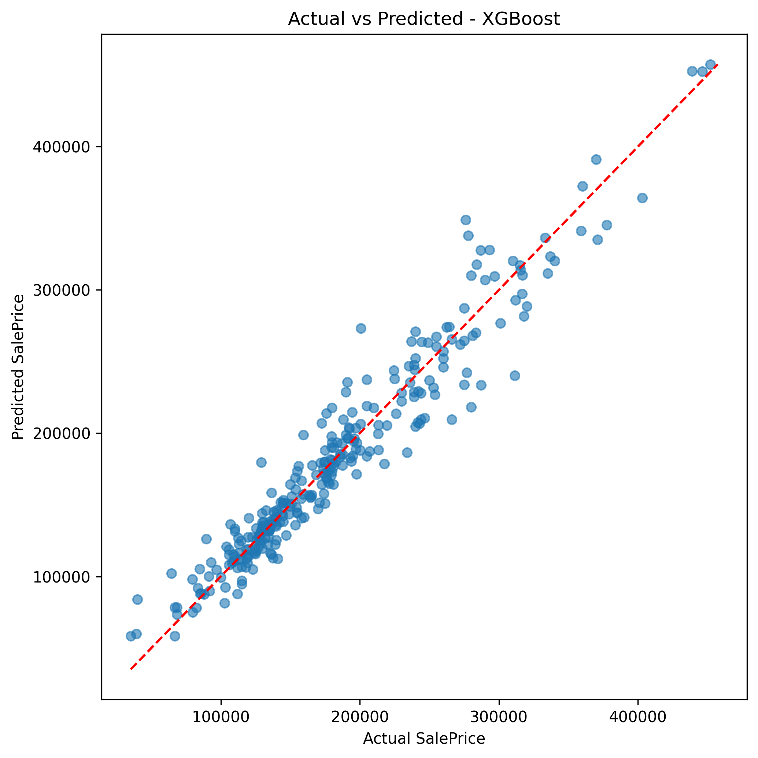

The figure 1 below compares actual selling prices against the values predicted by model, based on the algorithm that achieved the best performance (XGBoost). The dashed diagonal reference line represents perfect predictive accuracy. It can easily be seen that most data points cluster tightly around the line, which means that the model has successfully captured the underlying pricing patterns across the entire dataset. Predictive accuracy reached its highest level within the mid-range price segment, the tier containing largest volumed of observations in the dataset. Whereas, a slightly higher deviation was observed for higher prices. This phenomenon is easy to understand, as luxury properties are typically less common and often posses unique characteristics that are difficult for the model to fully capture through structural variables only.
B. Residual analysis
Figure 2. Residual analysis
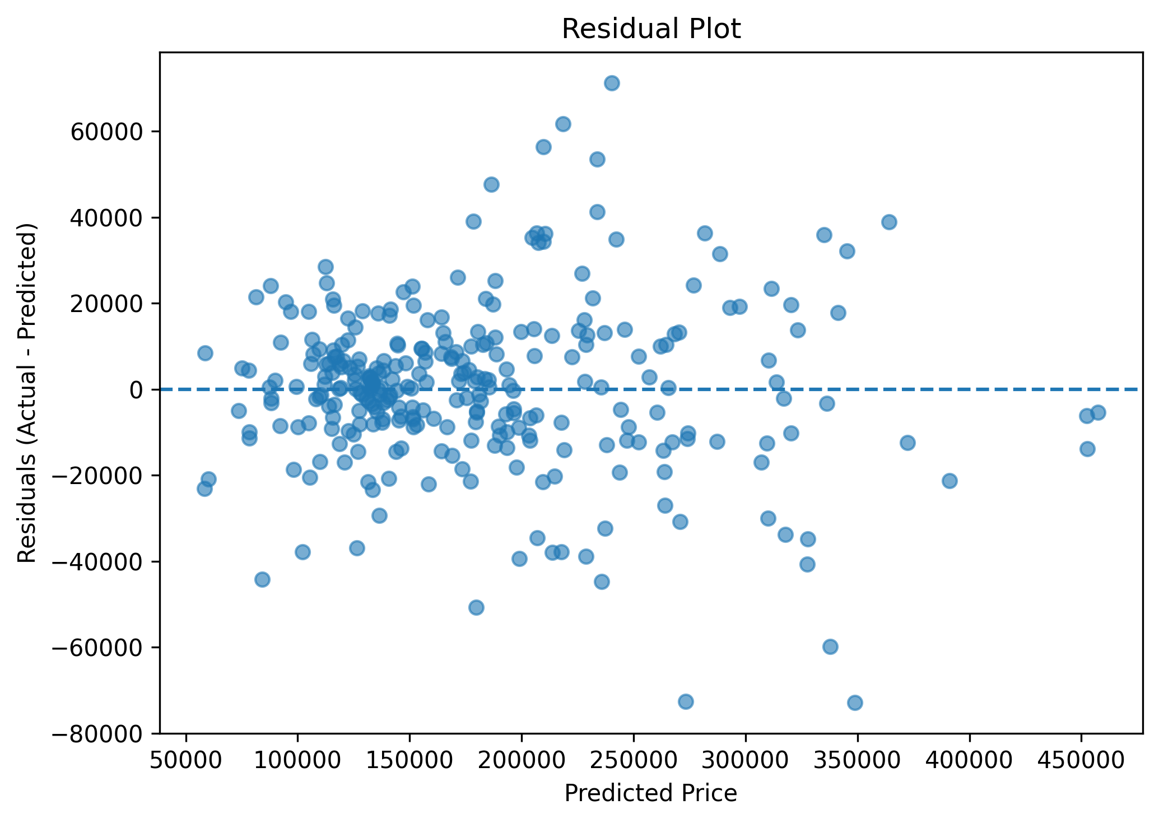 Residual analysis plays an important role because it helps detect whether the model suffers from any systematic errors. Residual analysis calculate using the following formula:
Residual = Actual Value − Predicted Value
A high-quality regression model should generate residuals that are randomly distributed around 0 and exhibit no discernible patterns. As we look deeper into Figure 2, the residual cluster around 0 and distribute relatively even across the range of predicted value. This show that the model does not exhibit a consistent tendency to either overvalue or undervalue properties. In other words, there is no strong connecting bias present in the predictions. There is no major curved patterns or directional trends were observed, which suggest that the models has successfully captured the majority of relationships within the data. Moreover, some greayer dispersion of residuals was noted in the group of expensive house, examining the higher degree of volatility in high-end markets.
C. SHAP explainability result
Figure 3. SHAP summary plot
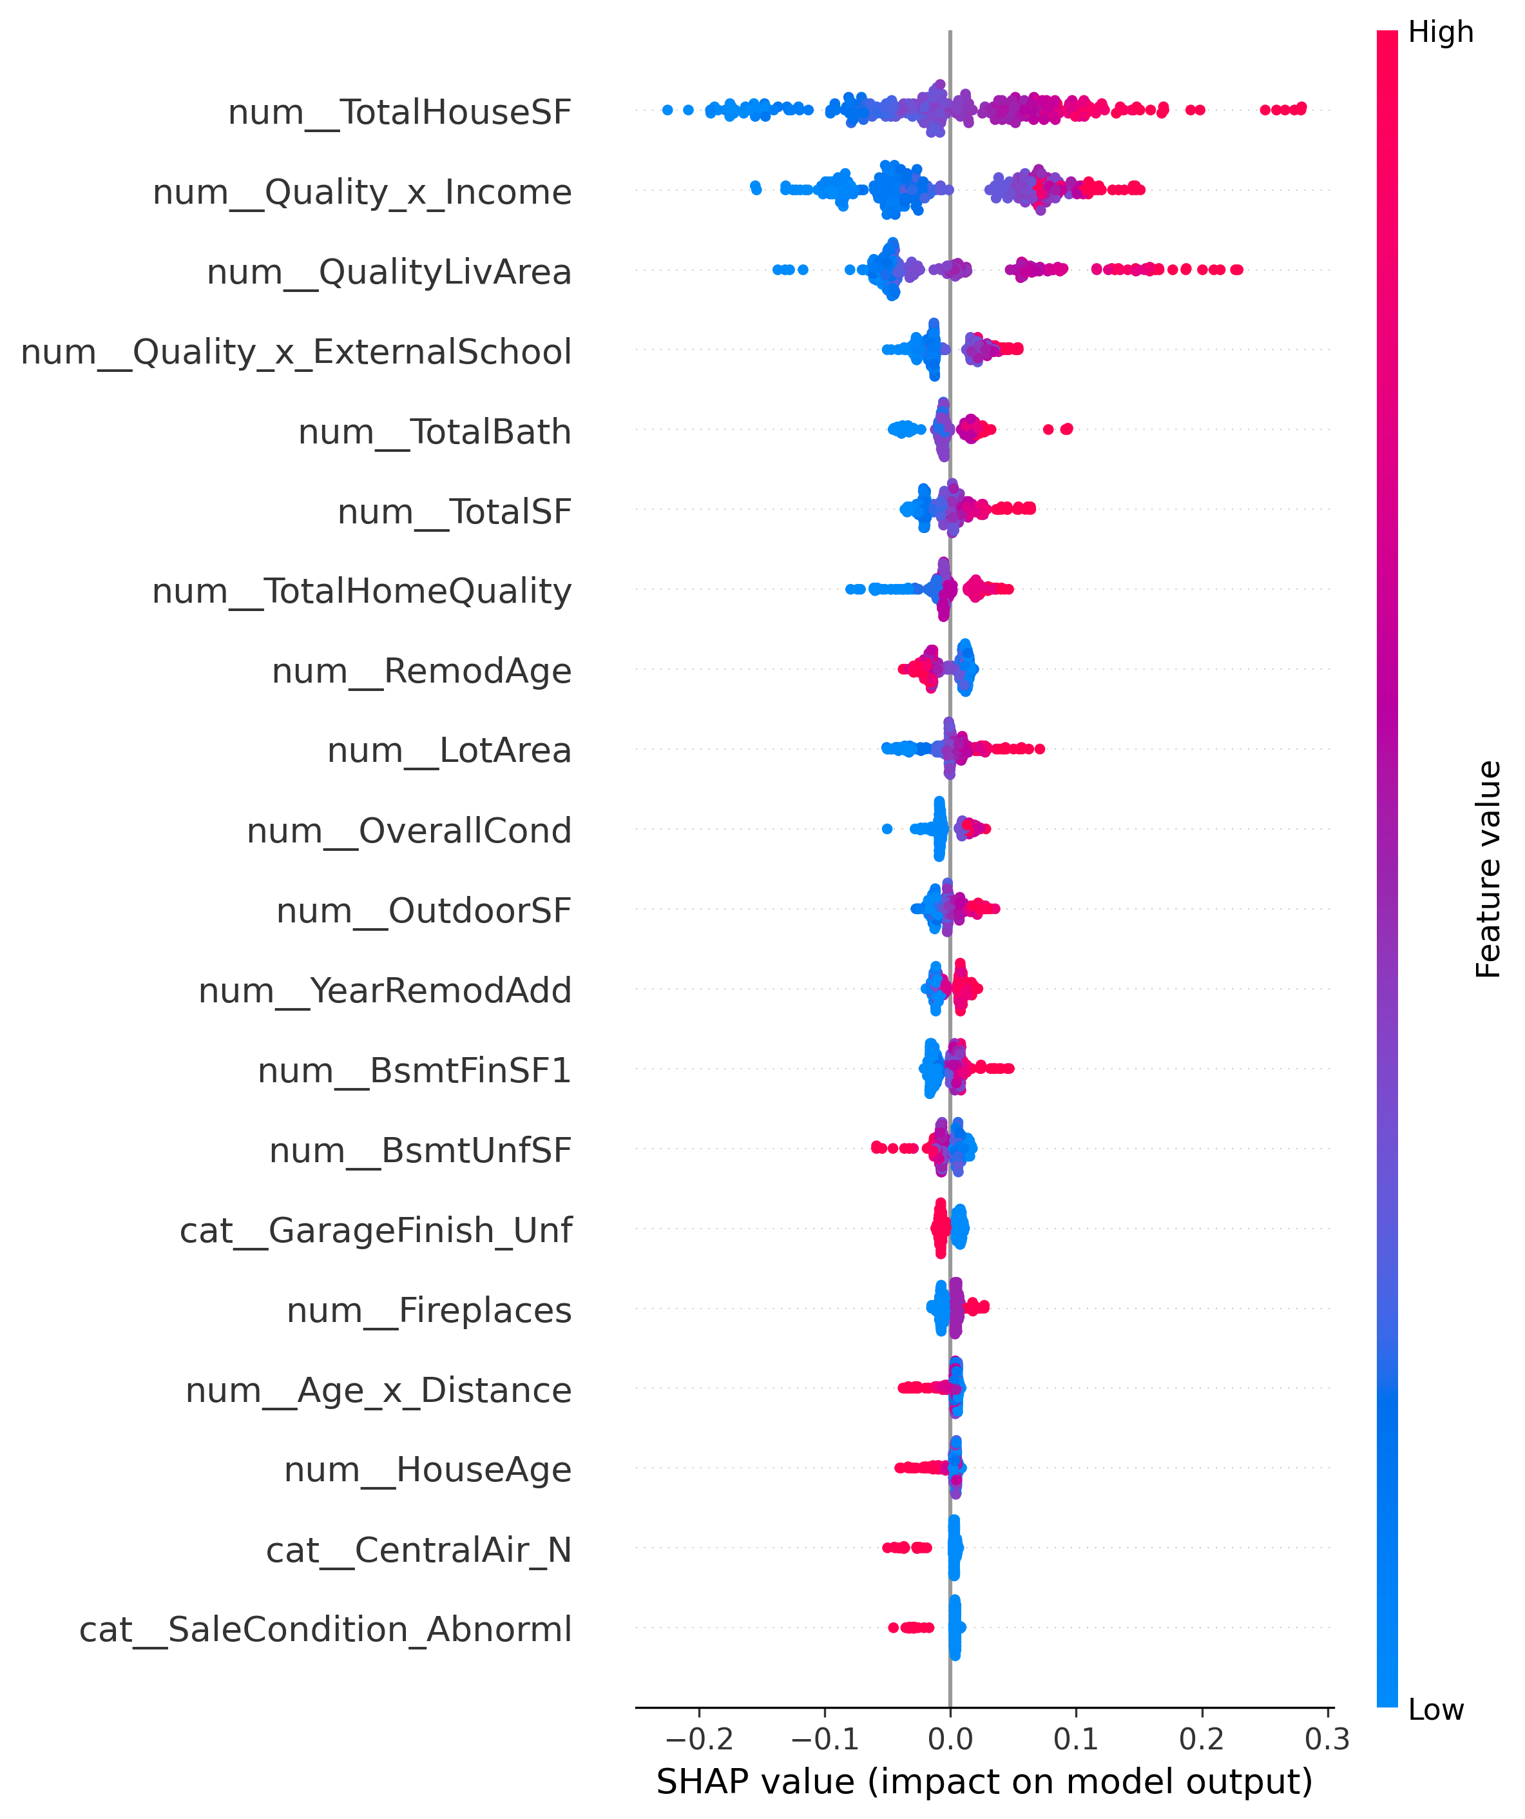
Even though advanced machine learning models can achieve very high accuracy, they are often criticized for operating like “black boxes”. To improve transparency, SHAP (SHapley Additive exPlanations) values have been added to explain how data features influence prediction outcomes.
In the SHAP summary plot, there are some key points we need to understand. The red points indicate high feature values, while blue points indicate low feature values. When the points were located further to the right, it contributed to an increase in the predicted value. In contrast, the points located further to the left contribute to a decrease in the predicted value.
In figure 3, the results from SHAP confirm that the following factors have a strong positive impact on the predicted sale price: larger total floor area, higher overall quality ratings, higher neighborhood income levels, higher school quality scores, a greater number of bathrooms. Conversely, houses of lower quality, with smaller floor areas or located in less developed neighborhoods tend to drive down the predicted value. The consistency between the model’s explanation and intuitive observations within the real estate domain reinforces the confidence that the model has learn economically meaningful relationships, rather than just capturing random statistical noise.
D. Interpretation of findings
There are several key insights that have been drawn from the results. First, ensemble learning methods clearly outperform simpler linear regression approaches. This confirms that real estate valuation is a nonlinear problem involving numerous interacting variables. Second, feature engineering techniques had a significant impact on performance. Variables such as Quality x Income or Quality x SchoolScore proved to be much stronger predictors than many original columns, demonstrating that domain expertise remains highly valuable. Third, external contextual information enhances practical relevance. Traditional housing datasets often focus solely on property structure, whereas actual buyers also prioritize neighborhood affluence, schools, and convenient location. Finally, interpretability methods revealed that the model’s logic is economically sound and consistent with some behavior that exists for a long time. In overall, the proposed framework achieved robust predictive performance while striking a balance between interpretability and practical utility.
VII. CONCLUSION
This study developed an advanced machine learning framework for predicting housing prices using the Kaggle Ames Housing dataset. To evaluate, several predictive algorithms were used, including Linear Regression, Random Forest, Decision Trees, Gradient Boosting, PCA+ Ridge Regression, Stacked Hybrid Trees, and XGBoost. In addition to algorithm comparison, extensive preprocessing and feature engineering techniques were applied to improve model quality as well.
The final result indicates that XGBoost with early stopping achieved the highest predictive accuracy among all tested models. The model then effectively captured nonlinear pricing behaviours and complex interactions among structual, quality, location and neighborhood variables. Validation plot demonstrated a close correspondence between actual and predicted prices, while residual analysis confirmed small amount of systematic bias.
One of the most significant contributions of this project is the creation of engineered variables. Some features such as Quality x Income, Living Area Quality or Total Housing Area importantly outperform many original features in raw dataset. This finding suggests that careful feature engineering can be just as critical as algorithm selection. Another key contribution is explainability. By using SHAP analysis, the model’s decision becomes more transparent and understandable. This is particularly valuable in real estate applications, where buyers, sellers, lenders, and investors require confidence in automated valuation systems. From a practical perspective, this framework can be utilized in mortgage appraisal, real estate investment screening, online real estate platforms, and supporting systems. It offers us a scalable approach to estimating market value that incorporates both property characteristics and neighborhood information.
Another big contribution of this study is the integration of an external dataset, comprising neighborhood-level information such as estimated median income, school quality indicators. Traditional housing datasets typically focus solely on the specific characteristics of individual properties, whereas, in reality, a home's value is strongly influenced by the conditions of the surrounding community.
In summary, the combination of advance machine learning model, external data integration, and explainable artificial intelligence can significantly enhance the accuracy of home price predictions compared to traditional methods. This project demonstrated how data science can transform real estate valuation into more accurate, transparent, and intelligent decision-making.

VIII. REFERENCES
[1] Z. Stojanovic, D. Galic, and H. Kahric, “Predicting Real Estate Prices Using Machine Learning in Bosnia and Herzegovina,” (2025). https://www.mdpi.com/2306-5729/10/9/135https://www.mdpi.com/2306-5729/10/9/135https://www.mdpi.com/2306-5729/10/9/135
[2] F. Mostofi, V. Toğan, and H. B. Başağa, “Real Estate Price Prediction with Deep Neural Network and Principal Component Analysis,” (2022). analysishttps://www.researchgate.net/publication/366979465_Real-estate_price_prediction_with_deep_neural_network_and_principal_component_analysis
[3] F. T. Neves, “The Impacts of Open Data and eXplainable AI on Real Estate Price Predictions in Smart Cities,”(2024). https://www.mdpi.com/2076-3417/14/5/2209https://www.mdpi.com/2076-3417/14/5/2209https://www.mdpi.com/2076-3417/14/5/2209

